Session 09 – Vistumbler Wei Cui

**Lab Objective**

* Submit a screenshot of Project 9-1 Viewing WLAN Security Information with Vistumbler
* Write a report including screenshots and written descriptions. Be sure to include a screenshot and description for step 11.

**Lab Results**

1. Lab Results Went to [www.vistumbler.net](http://www.vistumbler.net)
2. Downloaded and installed vistumbler
3. Clicked on Scan APs
4. Noted Signal and High Signal. How could this be used be used in a site survey?
   1. The APs can be sorted by Signal or High Signal (Strength). AP of highest or lowest signalest appears at the top.
5. Clicked on Graph 1
   1. Graph 1 below (Fig 1) shows the RSSI of one of the Wi-Fi over the time. number, the stronger the signal. In an IEEE 802.11 system, RSSI (Received signal strength indication) is the relative received signal strength in a wireless environment, in arbitrary units. RSSI is an indication of the power level being received by the receive radio after the antenna and possible cable loss. Therefore, the higher the RSSI number, the stronger the signal. In Graph 1, the RSSI is around -55dBm. The Channel is 165, and the signal is WPA2 encrypted by CCMP. It also lists Active APs and Actual loop time.
6. Clicked on Graph 2
   1. Graph 2 (Fig 2) shows the similar information as Graph 1 but a bar chart. Graph 2 shows RSSI strength with more details. We can see some white lines to indicate no signal and the variations around -55 dBm. Graph 1 shows an almost straight line without much variations. It can be concluded that either Graph 2 has a higher sampling rate or Graph 1 takes the average to smooth out the trend.

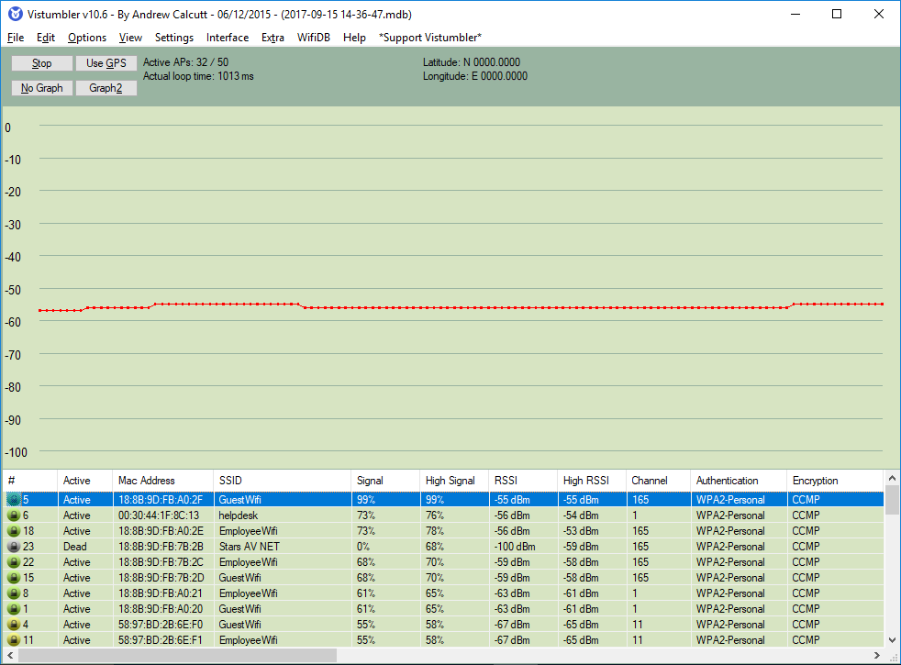

Fig. Graph 1: the signal strength of AP (GuestWifi) over the time.

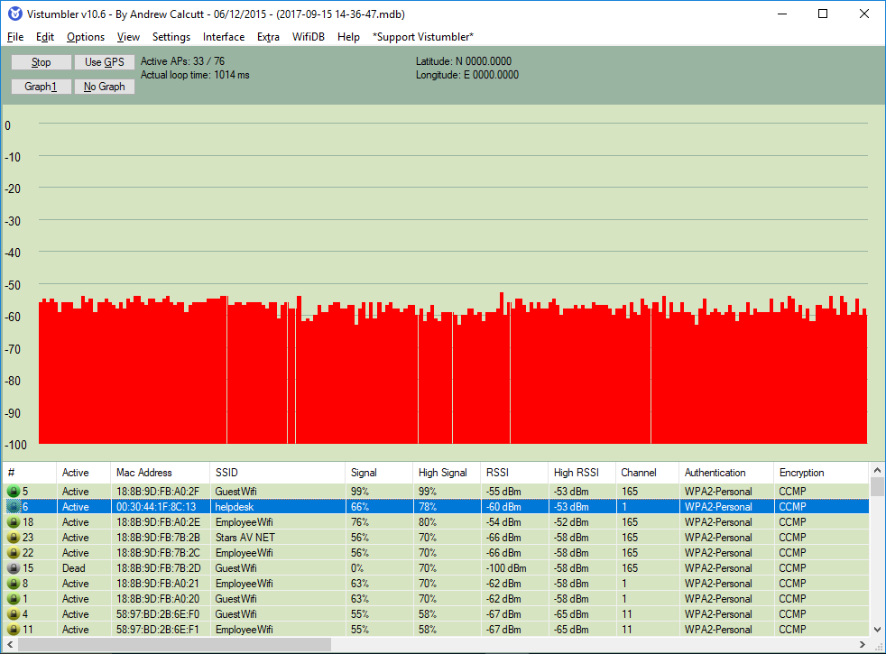

Fig. Graph 2: RSSI over the time in a bar chart with more details than Graph 1 (Step 11)